Problem Statement

1.Write a hive query to find the minimum temperature observed in a given weather station in a particular year.

2. Write a hive query to find the maximum temperature observed in a given weather station in a particular year.

3. Write a hive query to find the number of readings given by each weather station according to the dataset.

First we will create table weather using create command and then using show tables we can check for all the tables.

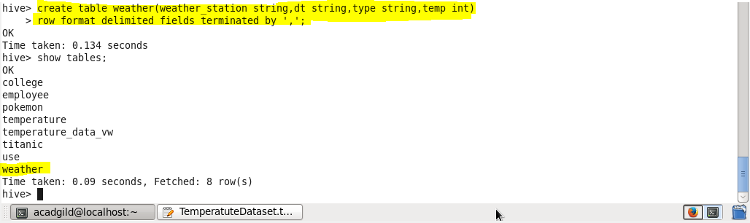

Now we will load our dataset temperature.txt to our table weather using LOAD command

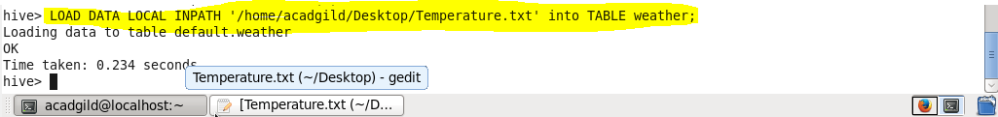

**Q.1. Write a hive query to find the minimum temperature observed in a given weather station in a particular year.**

We will use substring method to extract the year from the date.

We will use aggregate function min for finding the minimum temperature in that particular year

Then we will group our result by weather station name and that year

**Output**

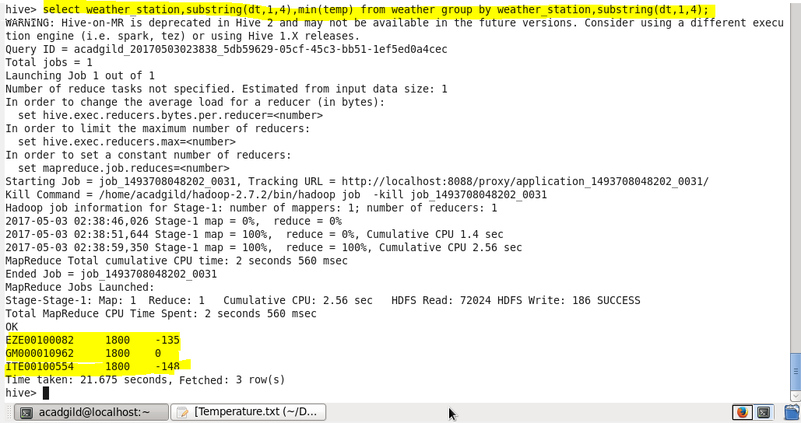

**Q.2. Write a hive query to find the maximum temperature observed in a given weather station in a particular year**

We will use substring method to extract the year from the date.

We will use aggregate function max for finding the maximum temperature in that particular year

Then we will group our result by weather station name and that year

**Output**

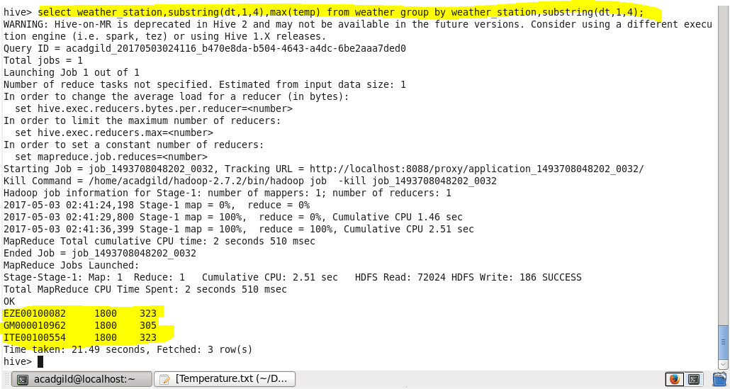

**Q.3. Write a hive query to find the number of readings given by each weather station according to the dataset**

We will select the weather station

For the number of readings we will use count function

And then we will group our result by weather station

**Output**

